**CONSTRUCTION MANAGEMENT SYSTEM**

**Description:**

Construction management application is an internal application used to manage the projects of the company with materials and workers associated. This application has home screen which shows the details of the application. Project tab which is used to add a new project, edit/modify or delete the existing project. Materials tab is used to add new materials edit/modify or delete the existing materials. Worker tab used to add new worker edit/modify or delete the existing worker.



**Tab Details:**

1. **Project –** In this tab we have “New” button which is used to add the new project.

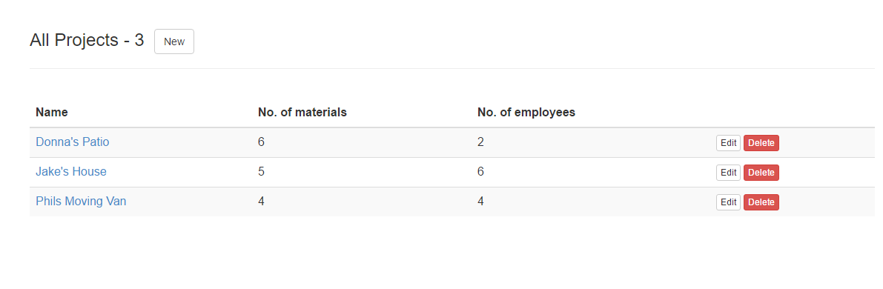

* When new button is clicked New project page gets navigated, in which we need to give the project name and description if any.

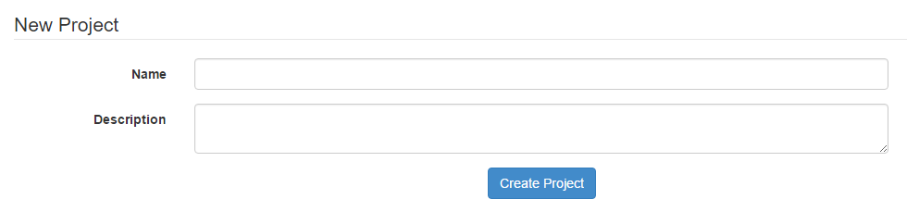

* Edit and delete button is available on the project page to modify or delete the existing project.
* After adding the project, click the project name (link) to add the materials and workers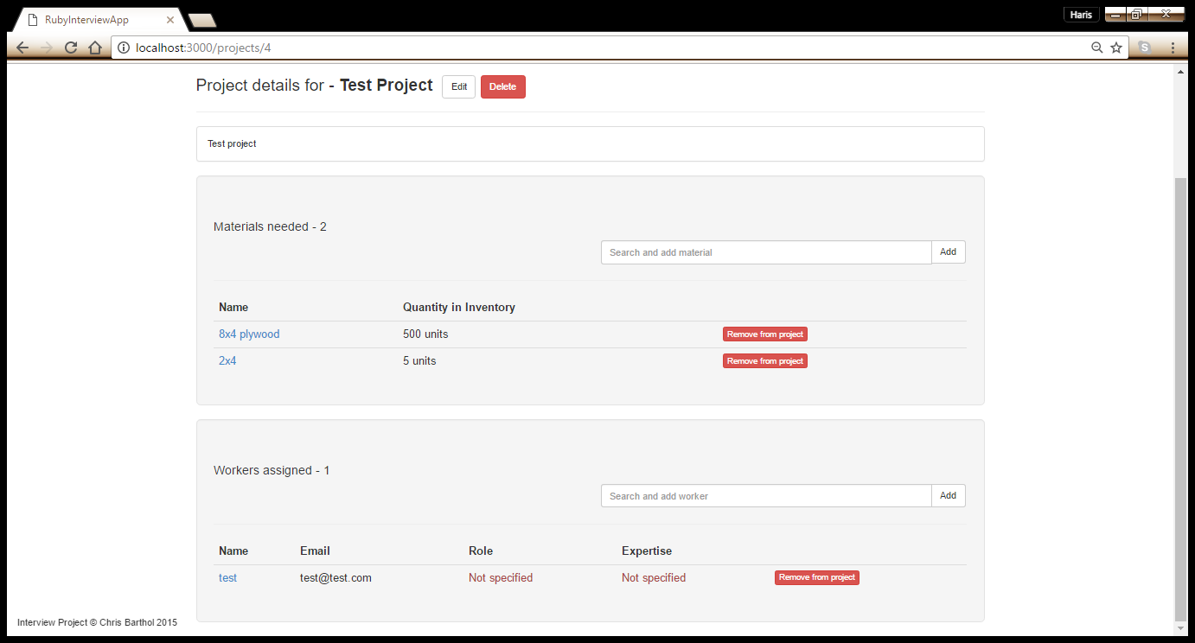
* Project page also displays the number of materials and workers associated to the project

1. **Materials –** Materials available for all projects. Can create new materials, edit/modify or delete the exiting material.

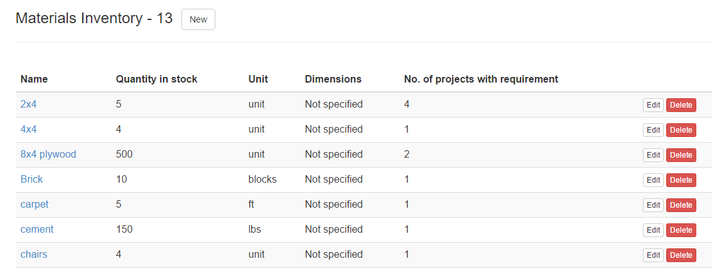

* Fields available while creating new material - Name, Quantity is stocks, Unit, dimension, No. of projects with requirement (this field shows total number of projects this specific material is associated)

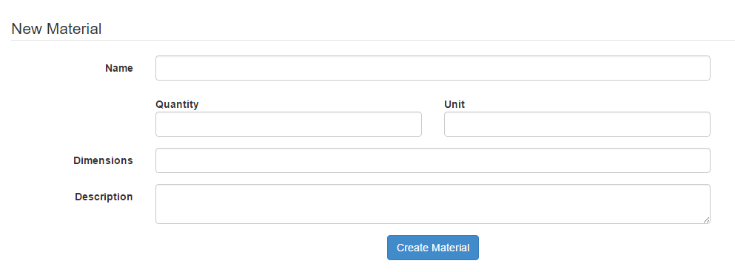

1. **Workers –** add new workers to the company, edit/modify or delete the exiting worker.

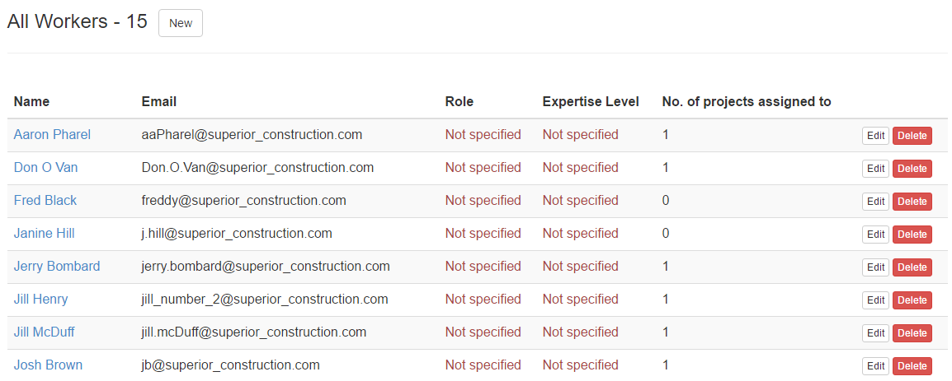

* Fields available while creating new worker - Name, Email, Role, Expertise level.

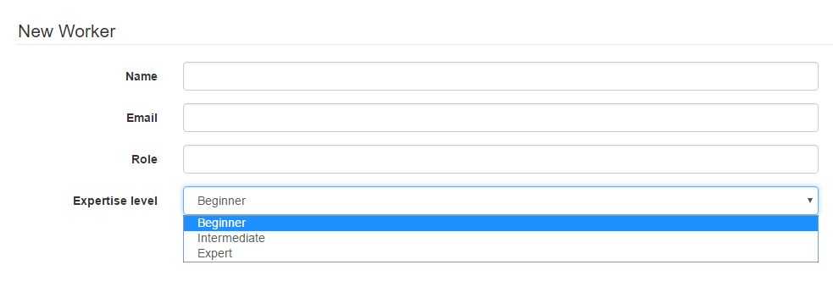

**Gem file updates:**

Added the below listed gems for this project.

|  |  |
| --- | --- |
| **GEM NAME** | **DESCRIPTION** |
| gem 'twitter-bootstrap-rails' | Bootstrap is a toolkit from Twitter designed to kickstart development of webapps and sites. It includes base CSS and HTML for typography, forms, buttons, tables, grids, navigation, and more. |
| gem 'will_paginate' | It is a pagination library that integrates with Ruby on Rails. It also have control to display number of records in a page |
| gem 'jquery-ui-rails' | This gem packages the jQuery UI assets (JavaScript’s, stylesheets, and images) for the Rails [asset pipeline](http://guides.rubyonrails.org/asset_pipeline.html), so you never have to download a custom package through the [web interface](http://jqueryui.com/download) again. |
| gem 'rails-jquery-autocomplete' | Gem used to list the values when part of the character is typed. |
| gem 'spring' | It speeds up development by keeping your application running in the background so you don't need to boot it every time you run a test, rake task or migration. |

**Database:**

* Used Sqlite as DB
* I use the same seed.rb and schema.rb from the sample project and updated the required schema for this project.
* This project have five tables

1. **Project** – to store new project
2. **Material** - to store new material
3. **Worker** - to store new worker
4. **Project_materials** – each project have number of materials associated to it. This table stores the project id with material id for reference
5. **Project_worker** – each project have number of workers associated to it. This table stores the project id with worker id for reference

**Application Flow:**

Models (.rb)

* Material
* Project
* Project_worker
* Project_material
* user

Views (.html.erb)

Layout

* Footer
* Header
* Application

Materials/Projects/workers

* Form
* Edit
* Index
* New
* Show

Static pages

* home

Config (routes.rb)

Browser (localhost:3000)

Controllers (.rb)

* Application_controller
* Materials_ controller
* Project_ controller
* Static_pages_ controller
* User_ controller
* Workers_ controller